# **Proposition**

# 

# Succeeding in business is not easy. But it can be simple. Be good. And let the world know.

If you are good at what you do, and people know it, they will want to do business with you.

**So the founders have two jobs.**

One is to build. That’s why founders obsess over users and their problems. That’s what makes them better than most.

The other is to let the world know.

But that’s another full-time job. Most don’t get to it. Their expertise stays hidden. Their story goes untold. The business suffers.

We do that second job for you.

You keep building. We make sure people know what you are building and why it matters. And you become Unstoppable.

# **Core-offering**

**Positioning**

The brand manager will have a detailed call with you to understand your goals and help craft your positioning.

While this is primarily a one-time exercise, your work and goals may evolve over time. Therefore, the brand manager may choose to revisit your positioning after 6–12 months. Any minor updates will be discussed and addressed during the regular POV calls each month.



**‘Mind’**

Our mission is to make founders unstoppable. One day, we want to build your digital twin. To help you get twice as much done every day.

Our first step is to help you build a second brain painlessly. We call it Mind. Don’t mind the name. Bad joke. Never mind.

Mind helps you express meaningful, thoughtful stories effortlessly. Stories that build credibility. Credibility that brings visibility. Visibility that expands your opportunity space.

‘Mind’ has memory, recall, and the ability to connect the dots.

It remembers key facts about you, your preferences, and your POVs from your calls with the brand managers, and from your voice notes. And your app activity. What you bookmark, agree with, or disagree with. It preserves the long-term context and becomes more like you over time. It updates itself after every call with your brand manager.

Using memory compression, *Mind* stores only what matters most. And recalls it when needed.

All this helps you express your thoughts on social media effortlessly.



**‘Voice’**

We train the AI to write in your unique style. By creating a reusable voice profile from your samples and preferences. It captures your tone, phrasing, and stylistic signals like cadence and word choice. This helps us create drafts that sound like you, not generic AI text.

The more samples you share, the better it gets. That’s why we update your voice after every call with your brand manager.

It mirrors your style, not your personal knowledge.

**Configured POV feed**

You can browse the POVs on the Feed tab. It’s made up of cards that extract the best POVs from the sources you follow. Like the podcasts, newsletters, blogs. As well as from topics and areas you are interested in. The feed is configured specifically for you. It is high on signal, low on noise. But that makes it dense.

We have learned that the fastest way to build or refine your perspective is to expose yourself to diverse POVs on the subjects you care about. This configured POV feed does exactly that. And more. It lets you agree or disagree with each POV and remembers your choices. Over time, these POVs become the building blocks for your Drafts.

**Drafts**

You will receive 60 drafts per month which should suffice for 15-20 posts.

Every day you will receive 2 drafts on your home feed. You can accept or reject them. The brand manager will work on the drafts you have accepted and turn them into posts. If there are no accepted drafts, the brand manager will work on the non-rejected drafts.

These drafts originate from POVs on the feed that you agree or disagree with, articles you bookmark, voice notes you record[1], or transcripts you share on the app.

**Posts**

15-20 posts per month. Starting with 2 posts a week and gradually increasing to 4 posts a week.

**Pricing**

All the above at ₹35,000 per month.

Only for customers starting in 2025.

All fees are paid in advance.

# **Add-on**

**Engagement**

@vishal

**Outreach**

@vishal

We recommend that you start with add-ons 2-3 months after the core offering after we are through positioning and have working alignment.

**Pricing**

Engagement and Outreach will cost additionally ₹10,000 on top.

All fees are paid in advance.

# 

# **Your posts**

## 

## We did a quick audit of your LinkedIn activity. Sharing a few snapshots from our AI audit tool.

**Snapshots**

| Original posts | 126 |
| --- | --- |
| Reposts | 32 |
| Most active month | Feb 2024 |
| Longest inactive | Aug 2023 - Mar 2025 |

One sentence on the above.

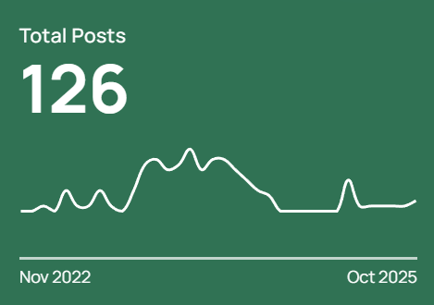

One sentence on the above.

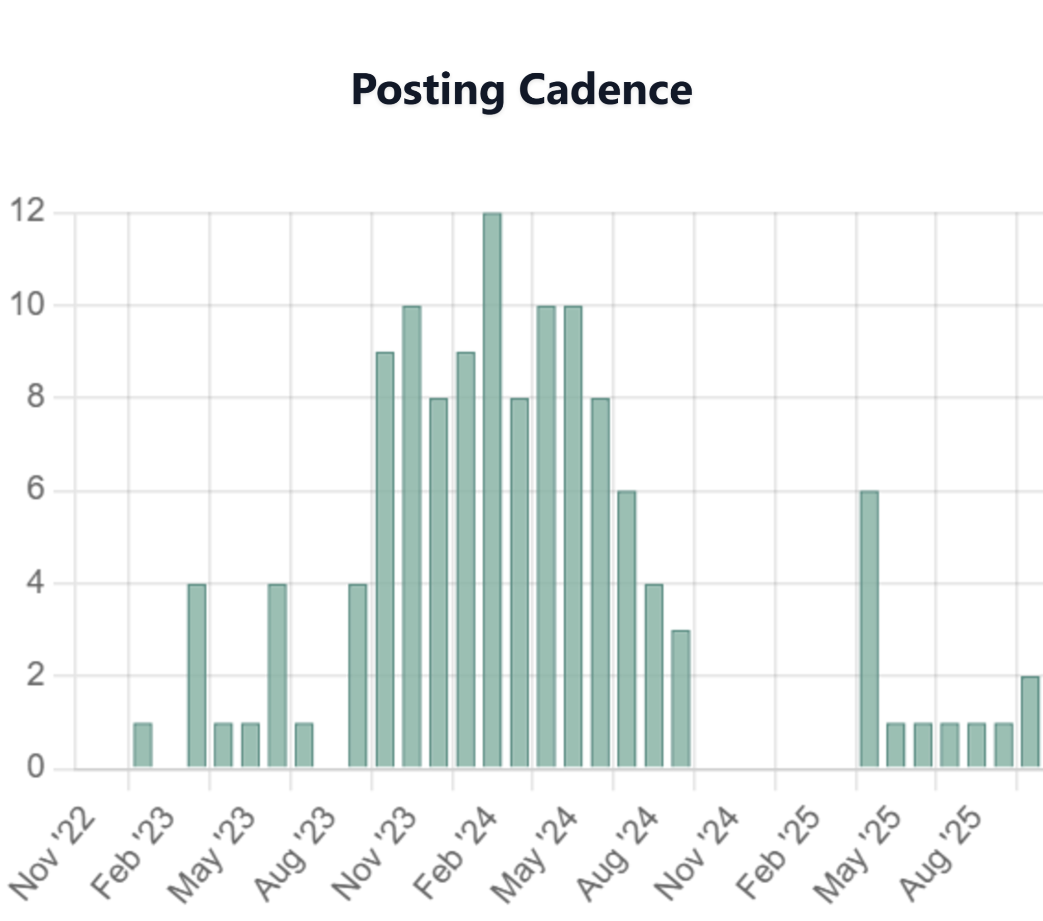

### 

One sentence on the above.

**FAQs**

**Q. My LinkedIn feed is just AI slop and cringe stories. Why would I want to add more junk to that pile?**

A. You're not wrong. AI makes it easy to sound clever, but then everyone sounds the same. No personality. Just noise.

But LinkedIn is just a platform. It's how people use it. Most people are chasing visibility because it is measurable and it is quick. But it costs them their credibility.

But if one can share thoughtful learnings, it builds credibility. Done consistently, it also builds visibility. Gradually, and then suddenly. Like most things that compound.

Also, most decision-makers are on LinkedIn. This makes it a strong channel for B2B founders.

**Q. Do I need you? Can I not do it myself?**

Yes, you can do it yourself using LLMs. But DIY comes with hidden costs. Mostly time and focus. And a bit of sanity. Because LLMs need to be reined in.

Even if you start strong, something urgent will eventually take over, and a week will quietly slip away. And then more.

**Q. Why you? I can hire an intern.**

You could hand it off to an intern.

But your brand voice might start sounding like a college assignment. And it’ll still be your job.

Founders juggle countless priorities. Product, distribution, fundraising, and five other fires every morning. What we do is take one of those spinning plates off your hands.

Over time, we build your second brain. You share your raw thoughts. We handle the grind. We draft posts in your voice. And we do it consistently.

**Q. What's the rush?**

Each day is like perishable inventory. It carries its own opportunity cost.

Each day your competition is building their distribution, strengthening their narrative.

Each day they are moving ahead and compounding.

And if you are not moving ahead too, you are falling behind.

**Q. How much time commitment is required from the user?**

1-2 calls with the brand manager per month. And 5-10 mins on the app daily. App time does not cost much as it comes from your idle time in between important stuff. So practically it is 1-2 hours per month. Final post approval time is not included as it depends upon how much time you want to invest.

In addition there is also a one-time investment of up to 3 hours initially to set expectations and establish brand positioning.

**Q. Why do you have a human in the loop?**

We’ve learned that the best results come when AI and humans work together. AI brings deep knowledge, memory, the ability to connect the dots, and tireless efficiency. Humans bring judgment, empathy, brand intuition, and strategic thinking.

Our brand managers speak with customers to understand positioning. They review, edit and refine every draft to make sure it’s meaningful and on-brand. In doing so, they also help train our models on you, building your unique Mind.

1. coming soon